**Department of Electronics and Telecommunication Engineering**

**Module wise University Questions**

**(First Half of 2023)**

**Class/Sem: BE/VIII Branch: EXTC**

**Subject: OC**

**Module 4: Optical Network System Components and Optical Networks**

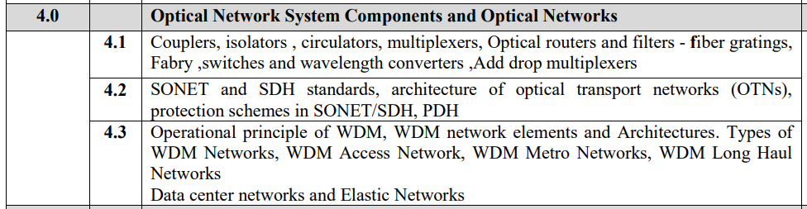

**Dec 2019**

1. Explain the concept of fiber bragg grating. Give its applications [05]
2. Write short note on optical switches [05]

**May 2019**

1. What is fiber bragg gratings? Give its applications. [05]
2. Draw the frame of SONET and determine its basic rate [10]
3. Explain the advantages of OTN over SONET [05]

**May 2018**

1. Explain the working principle of optical circulator [04]
2. Write a short note on: Fiber bragg grating [05]
3. Define four wave mixing (FWM) [05]
4. What is optical amplifier [04]
5. WDM network and architecture [05]

**Dec 2017**

1. Define four wave mixing (FWM) [05]
2. What is DWDM. Mention its advantages and disadvantages [05]
3. Write a short on: SONET/SDH [10]

**May 2017**

1. Compare isolators and circulators [05]

**Dec 2016**

1. Explain four waves mixing [05]
2. Draw architecture of SONET/SDH and explain in brief [10]
3. Differentiate between the optical components: isolator and circulator [05]
4. Write short note: WDM network element and architecture [05]
5. How DWDM id different from WDM [04]

**May 2016**

1. Explain the working principle of optical switches [05]
2. What is WDM? Explain the architecture of WDM with network component [10]
3. Short Note : d. Wavelength Stabilization[05]
4. Explain Grating principle & Fiber Bragg Gratings
5. What are optical couplers? Explain functionality of 2 ××2 fiber coupler.[05]
6. What are the elemnets of SONET/SDH infrastructure?

**Dec 2015**

1. Short note on Optical Multiplexer & Filters[05]
2. What are optical amplifiers. Explain different types of front end amplifiers [07]
3. Explain Grating principle[08]
4. Short note on Arrayed Waveguide Grating[08]
5. Explain coupler performance parameters[10]
6. Short note on Optical Isolator[10]
7. Differentiate DWDM, WDM and SONET [05]
8. Explain SONET architecture in detail [05]

**May 2015**

1. Short note: WDM[05]